

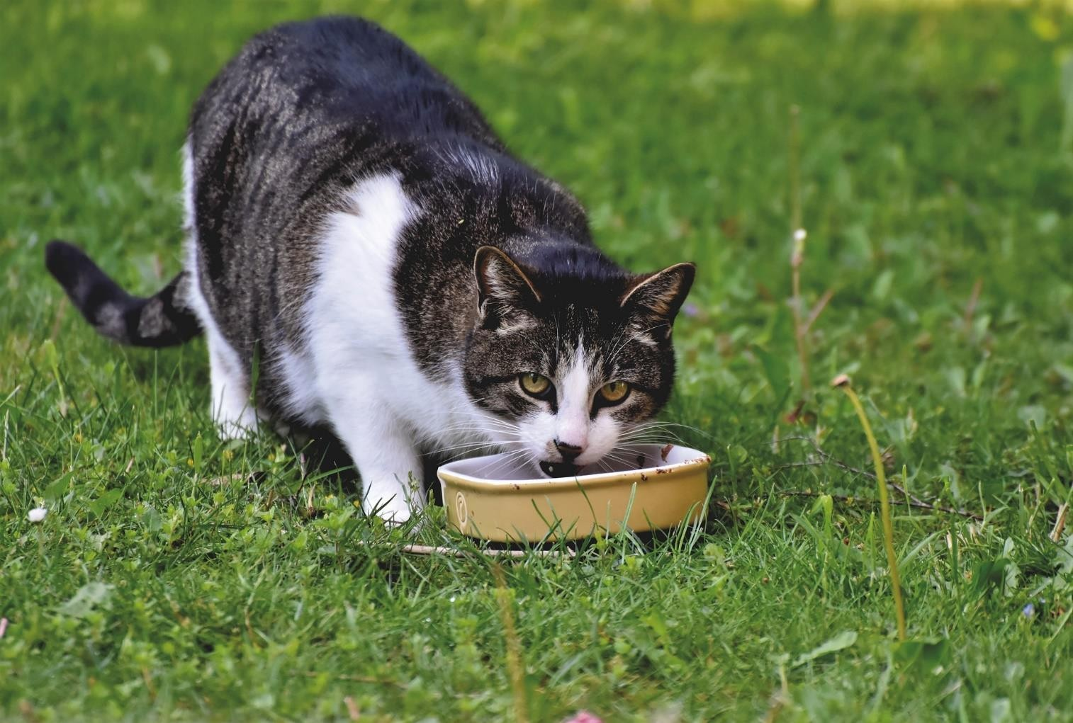

**Radioactive iodine therapy in hyperthyroid cats**

Afbeelding met Lettertype, Graphics, schermopname, ontwerp

Door AI gegenereerde inhoud is mogelijk onjuist.Brochure 2025

# **WHAT IS HYPERTHYROIDISM?**

Your cat has been diagnosed with hyperthyroidism, one of the most common hormonal problems in aging cats. This is the overproduction of thyroid hormone. Most often this is caused by a benign tumor (hyperplasia or adenoma), only rarely do malignant growths occur in the cat. However, this tumor must be treated: the overproduction of thyroid hormone has a lot of influence on the metabolism and can have harmful consequences for the cat.

The symptoms develop gradually and often it is not immediately clear that something is wrong. The most common symptoms are increased appetite (begging or even stealing food) and losing weight. Because the cat still eats well, it does not seem to be sick immediately. However, due to the excess hormone, the cat needs much more energy, which it tries to compensate for by eating more. If this is not enough, the cat will 'burn' the fat reserves and eventually the muscles as an energy source. Other symptoms include frequent vomiting, more drinking and urinating, seeking more attention, showing busier or even aggressive behavior, a high heart rate and/or a poorly groomed coat.

However, none of these symptoms are exclusive to hyperthyroidism and can also be caused by other diseases. A visit to the veterinarian is therefore necessary to determine the cause.

A minority of cats are more likely to show atypical symptoms, such as decreased appetite or even anorexia, they become drowsy and slower. In this case,

further investigation into an associated disease is essential. For this, a consultation with a specialist in internal medicine is indicated.

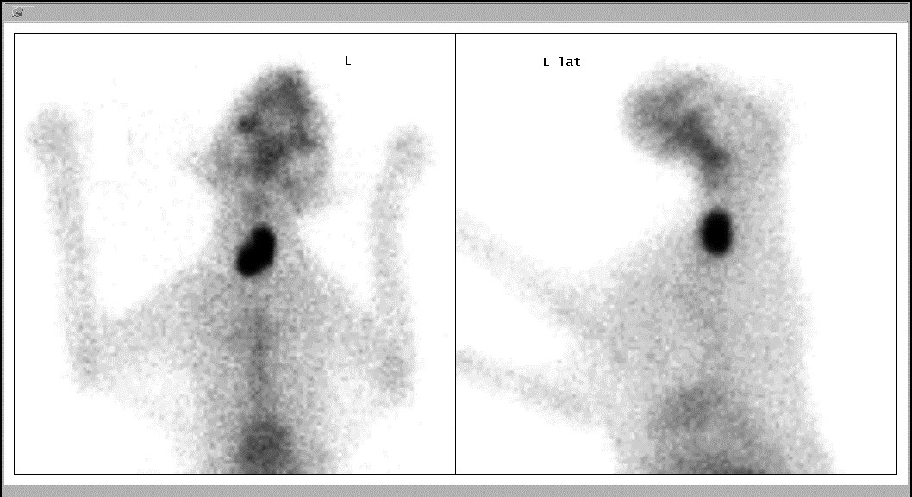The diagnosis is made on the basis of a blood test, which shows an increase in the thyroid hormone (thyroxine or T4). It is best to carry out a complete blood test, to detect or exclude other diseases.

**WHICH ARE THE TREATMENT OPTIONS?**

There are various treatment options: lifelong medication, an adapted iodine- poor diet, surgical removal of the affected thyroid gland(s) or the use of radioactive iodine.

1. MEDICATION (METHIMAZOLE, CARBIMAZOLE)

Medication should be given daily (1 or 2 times) for life. Not all cats are equally easy to take medication. Regular blood tests are needed to monitor the cat's condition and adjust the dosage of the medication. In a number of cats, side effects can occur due to the medication, such as severe liver problems, gastrointestinal complaints, severe itching, bone marrow suppression, ... When these side effects occur, the medication should be stopped. Since this treatment does not eliminate the cause of the hyperthyroidism, the benign tumor can greatly increase in size over time, and in some cases even show signs of malignancy. Increasing the dose is often necessary over time.

1. LOW IODINE DIET (HILL'S Y/D)

A low-iodine diet prevents too much thyroid hormone, for which iodine is necessary, from being produced. However, it cannot be used preventively. In addition, it is very important that the cat only eats that food (no sweets!), making it more difficult to give to outdoor cats, when there are several cats in the family, when the cat does not like the diet or when another diet is necessary (e.g. for diabetes).

Since this treatment does not eliminate the cause of the hyperthyroidism, the benign tumor can greatly increase in size over time, and in some cases even show signs of malignancy. Little is known about the long-term efficiency of the diet.

*Trial treatment with medication or the low-iodine diet may be appropriate in some cases, such as cats with concomitant other diseases or suspected kidney problems, but are not required for treatment with radioactive iodine.*

1. SURGICAL REMOVAL OF THE THYROID GLAND

Removal of the thyroid gland(s) or thyroidectomy is effective but has several disadvantages. Cats with hyperthyroidism are usually older and often have heart defects that make them not a suitable candidate for the anesthesia needed for this operation. When removing the thyroid glands, the nearby parathyroid glands can be damaged or taken away, which can cause additional complications such as calcium deficiency.

In addition, ectopic thyroid tissue (= small areas of thyroid tissue along the trachea or thyroid tissue in the chest cavity) may be present that cannot be removed surgically. Often both thyroid glands are affected. When only 1 thyroid gland is removed, it cannot be excluded that in the long term the other thyroid gland also becomes hyperactive, and therefore a second surgery is needed. Preventive removal of both thyroid glands is not recommended.

1. TREATMENT WITH RADIOACTIVE IODINE

The big advantage of using radioactive iodine (131I) is that it is an easy and non-invasive treatment. Because the radioactive iodine is injected through a catheter and absorbed from the blood into the thyroid glands, it reaches all thyroid tissue that works too fast, including the tissue that is located in the chest, for example. Like surgical removal, this is an irreversible therapy. However, there is no risk of damage to the parathyroid glands, and very few side effects are known.

The success rate is high: 90 to 95% of cats have a normal thyroid function after

only a few weeks, in some cases it can take up to 6 months before the thyroid hormone has reached a normal level. Only a small percentage of cats become hyperthyroid again over time.

A small proportion of hyperthyroid cats remain hyperthyroid after the first treatment with radioactive iodine. Often these are cats that have been hyperthyroid for a long time and have been treated with medication or Y / D and have developed a large thyroid tumor, sometimes there is even a possible malignant change. A second treatment may be necessary and can be carried out without any problems. Although most patients respond well to a second treatment, there are still a fraction of these patients who have not been fully treated.

On the other hand, there are also cats that react too strongly to radioactive iodine therapy. Often there is still enough normal thyroid tissue present after the treatment to produce a normal amount of thyroid hormone. However, some cats have too little thyroid tissue left, and produce too little hormone. This is often temporary and then we speak of a transient hypothyroidism (the opposite of hyperthyroidism). However, if it persists for more than 6 months, if the cat gets clinical complaints (such as drowsiness, dull coat, overweight, ...) or if other organ systems (especially the kidneys) are bothered by the shortage of thyroid hormone, it is recommended to supplement thyroid hormone. This is an easy treatment in the form of a pill or syrup that can be mixed into the feed. Thyroid hormone or thyroxine supplementation has no known side effects and is well tolerated by the cats, unlike thyroid inhibitors that can cause serious side effects.

The cost of radioactive iodine therapy is approximately 1300 euros (scintigraphic examination, treatment and hospitalization from Monday to Friday incl.).

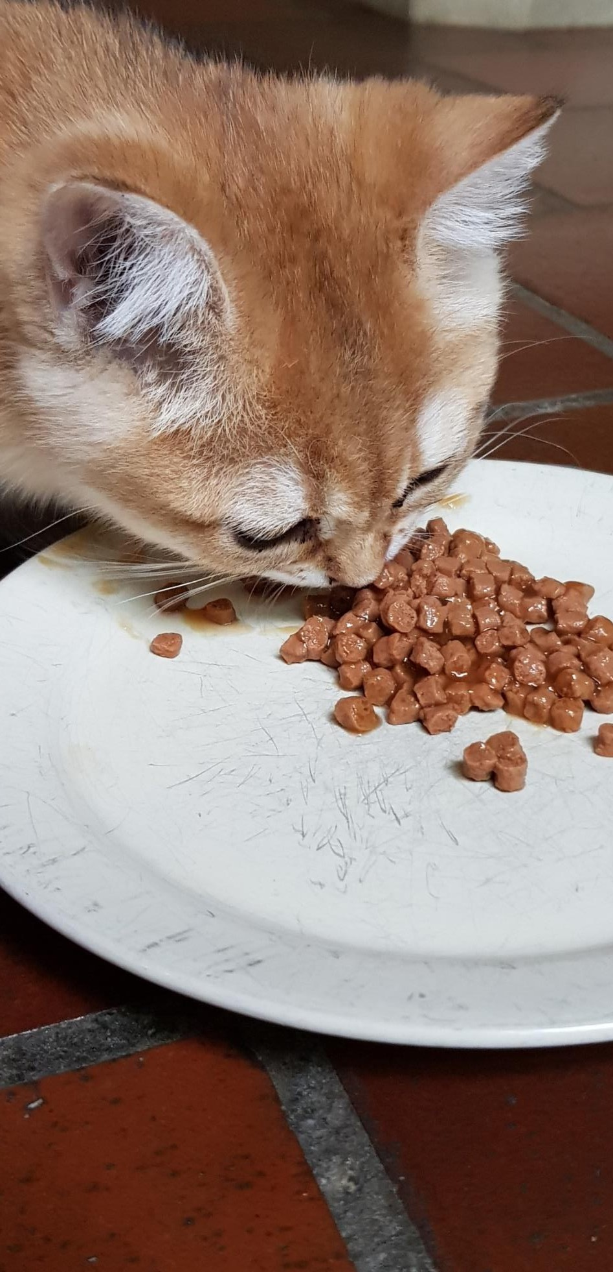

4

**HOW DOES RADIOACTIVE IODINE (131I)**

**WORK?**

In order to function properly, a thyroid gland needs iodine. The thyroid gland makes no distinction whether the iodine comes from the diet or is injected, nor whether it is radioactive or non-radioactive iodine. The cat's hyperactive thyroid tissue accumulates the radioactive iodine (in this case: 131I). The radioactive iodine then releases its radiation to the cells that work too fast.

One part of the radiation (beta particles) is released very locally (maximum 2 mm all around) so that the affected thyroid cells are destroyed. In this way, only the affected thyroid tissue is treated and the normal tissue is spared. Normal thyroid tissue often lies temporarily still for a while, suppressed by the excessive thyroid function of the affected thyroid gland. The parathyroid glands that lie outside the thyroid gland also remain unharmed.

Another part of the radiation, the gamma rays, do leave the cat, and allow us to check the absorption of the radioactive iodine in the thyroid gland with a special camera (the gamma camera). This is also the part of the radiation that we as veterinarians or as owners are exposed to when we are near the cat.

The part of the radioactive iodine that is not absorbed by the thyroid gland leaves the body through urine, feces and saliva. Therefore, the patients must stay with us for a few days after the treatment (most of the radioactivity is excreted during the first 72 hours after the treatment) and you must also take precautions at home afterwards (see below).

The big **advantage** of this treatment is that *no major actions* are required (such as surgery), that only a *short or even no sedation* is needed (for the diagnostic scan, see below) and that the majority of patients only need one treatment. In addition, the extra or *ectopic tissue* (which may be in the chest) is also treated.

The **disadvantage** of the treatment is that we work with radioactivity, and that your cat has to be hospitalized for a few days. Furthermore, this also means that you will have to respect some measures after returning home (see below).

**WHAT PROCEDURE DO YOU FOLLOW?**

### If your cat will undergo radioiodine treatment, it is crucial that she is stable and healthy enough beforehand.

This is especially true because:

1. Senior cats are more likely to have **additional diseases**. Hyperthyroidism usually occurs in older cats, which are more susceptible to other conditions such as kidney or heart problems.
2. **Restrictions after treatment**. Up to 3 weeks after radioiodine treatment, due to the risk of radiation exposure, it is more difficult to perform an extensive examination or provide intensive medical support to the cat, should this be necessary.

Therefore, to ensure as much as possible that your cat can safely undergo the treatment, you should visit your own vet for an extensive health check-up within four weeks before the scheduled appointment. This examination includes:

1. Thorough physical examination, with special attention to palpation of the thyroid gland and cardiac auscultation.
2. Complete blood test, including hematology, biochemistry and thyroid values.
3. Urinalysis (preferably) and, if possible, blood pressure determination.

The results of all these examinations (physical findings, blood and urine values, and thyroid values) should be emailed to [katomic@ugent.be](mailto:katomic@ugent.be) no later than one week before treatment.

Some owners prefer to have their cat thoroughly examined at our university clinic beforehand. This is also a possibility.

You can make an appointment for this at the Endocrinology department (Tuesdays) via our reception on +32 9 264 77 00.

**During the preliminary examination by your vet, it may happen that a cardiac arrhythmia or a heart murmur** is discovered on your cat's heart.

In such cases, it is important to take additional steps:

1) With **cardiac arrhythmias or a third heart tone** (galloping sound), a comprehensive cardiological examination, including echocardiography, is ‘mandatory’ before radioiodine treatment can possibly proceed.

2) With a **heart murmur**, the situation is slightly different. Many cats develop a heart murmur as a result of their overactive thyroid gland. This heart problem may improve or even disappear once the thyroid is back under control. Therefore, a cardiac examination for a heart murmur is not ‘mandatory’, but we strongly recommend it because an echocardiography sometimes reveals cardiac changes that need to be addressed directly in addition to thyroid treatment. Sometimes the echocardiography will indicate an increased risk of blood clot formation, requiring preventive medication. In many cases, however, echocardiography will confirm that the heart problem will largely recover once thyroid function is normalized, which is why we do not want to ‘oblige’ this examination and the extra cost.

If you already know in advance that your cat has a heart murmur and you wish, prior to treatment with radioiodine, to have a cardiological examination at our clinic, we can - if you let us know in time - schedule an appointment with our cardiologist.

A cardiological examination cannot be guaranteed to take place if a new heart murmur is detected on the day of radioiodine therapy.

### How to handle in case of relevant abnormalities during the preliminary examination by your veterinarian?

If relevant abnormalities are found during the preliminary examination by your vet, and you are still considering radioiodine treatment, there are two options that logically depend on the abnormalities found:

1. **Your own vet investigates the abnormalities**. Your vet can assess whether or not your cat should be referred to a specialist in your area for further diagnosis and treatment.
2. Together with your vet, you can also choose to **make an appointment at our clinic's Endocrinology department**. Here we will discuss the examination results and perform any additional investigations. Only after thorough examination and evaluation can we decide whether therapy with radioiodine can be safely scheduled.

In cats with an overactive thyroid gland, a *mild rise in liver enzymes* is regularly noted during blood tests. This is usually no cause for concern unless your cat is eating badly or showing signs of jaundice.

If new abnormalities are detected at our clinic on the day of the radioiodine therapy appointment, it is important to know that we cannot guarantee that an examination by an internal medicine specialist can take place the same day.

### By being thorough, we guarantee that your cat is in optimal condition for safe and successful radioiodine therapy.

**Possible scenarios**: there are roughly 3 different scenarios possible before your cat receives radioactive iodine treatment.

1. **No medication**: you choose to have the radioactive iodine treatment carried out immediately. This can be done, for example, when the cat does not want to take or does not tolerate the thyroid-inhibiting medication.

In that case, we ask for an extensive blood test (see above) that is up to

4 weeks old. If it is older, have a new study done. It is important to have the thyroid and kidney function checked properly after the treatment.

2. **A short period with thyroid inhibitors / iodine-poor diet**: it may be advisable to give thyroid inhibitors for a short test period in order to be able to check kidney function with a normal amount of thyroid hormone.

A thyroid gland that works too fast can cause the kidneys to appear to be better than they really are (“falsification” of kidney function).

By giving the medication for a few weeks, the amount of thyroid hormone will decrease and the actual kidney function will be visible. This is certainly interesting in cats that already have rather high kidney values with an excess of thyroid hormone. It is not true that the treatment of hyperthyroidism causes kidney failure! In the short term, an excess of thyroid hormone can somewhat support kidney function (hence the improved kidney values), but in the longer term, the kidneys will even be damaged if the hyperthyroidism is not treated.

3. **A longer period with thyroid inhibitors / iodine-poor diet**: some cats have been receiving thyroid-inhibiting medication for a long time (months or even years). If you still decide to proceed with radioactive iodine treatment, we ask you to request the complete file of the cat from your veterinarian.

A recent blood test is needed to determine the TT4 and kidney function, while the cat is still receiving medication. If both are good, you can make an appointment with us.

At the time of radioactive iodine treatment, the cat must be off the medication for 2 weeks. In the second week that you stop the medication, you have a blood test done on Wednesday for TT4 determination. This gives us information about the extent to which the thyroid gland is affected.

*(Note: in consultation we can decide to shorten the medication-free period. For this we need all the data from the patient, in order to be able to assess the clinical condition as well as possible.)*

**WHAT DO YOU DO ON THE DAY OF THE TREATMENT?**

* An overactive thyroid gland can cause additional stress sensitivity. Therefore, we recommend administering Bonqat or Gabepentin 2 hours before leaving home, this in consultation with your vet.
* The cat must be sober: food is allowed until the day before (up to 10 p.m.). On the day of admission, do not feed the cat in the morning. Water is always allowed.
* Bring a pillow or a blanket that the cat is familiar with (*Attention: this may not be returned!*). This sometimes helps the cat to get through the hospitalization period more easily.
* You may bring some of the cat’s favorite food. Cats sometimes dare to be picky and their own familiar food can help to eat well during their stay with us.
* As mentioned earlier, stop the thyroid inhibitors such as Felimazole, Thiafeline, Carbimazole (cream or tablets) or the Y/D diet 10 days before admission **unless otherwise agreed**.
* Please continue to give administer **other medication** (e.g. for the heart) and also bring it with you.

**HOW DOES THE TREATMENT WORK?**

* You bring your cat in on **Monday** between 8:30 and 11:30 a.m.
* An intravenous catheter is placed in the front leg. This is necessary to administer the sedation/anesthesia and the pertechnetate for the diagnostic scan. We perform a *diagnostic scan* (or *pertechnetate* *scan*) before determining the dose of radioactive iodine. This scan takes 1 to 2 minutes. Usually, the cat is briefly put under anesthesia.
* We use a fixed dose of radioactive iodine, orally (by mouth) administered when the cat is superficially sedated.
* During the hospitalization period, we check the amount of radiation emitted by the cat. We do this by keeping a dose rate meter or Geiger-Müller counter close to the cat. Every day, the litter box is checked and changed and the cat gets fresh water and food.
* During the night, there is no permanence at the nuclear hospitalization unit.
* The length of hospitalization depends on the rate at which the activity that the cat radiates, decreases. Under normal circumstances, your cat returns home after 4 days (on **Friday** after the radioactive iodine treatment). Afterwards, there are still some measures to be respected to limit contact with radiation as much as possible: see further “what after the treatment?”.
* Because of residual radioactivity, the return journey after treatment can only be made by *personal* transport (no public transport such as train, bus or metro!). No pregnant women or children are allowed in the car and a minimum distance of 1 meter between cat and attendants must be respected. We recommend placing the cat in the car trunk without any persons in the back seat. If you cannot comply with these safety rules, limit the car journey to 2 hours.
* In the rare case that a cat dies during hospitalization, the body can only be released after 10 weeks.

**WHAT SHOULD YOU DO AFTER THE TREATMENT?**

The first 2 weeks after returning home, follow the following simple **guidelines**:

* + NO contact between the cat and pregnant women or young children. Also, keep the litter box away from them.
  + Limit contact with the cat: do not let the cat sleep on the bed, do not keep it on your lap for too long, … A short stroke or hug are no problem, provided you wash your hands afterwards.
  + Preferably the cat stays inside for 2 weeks.
  + Avoid contact with urine, feces and saliva. Wear disposable gloves when changing the litter box and wash your hands thoroughly afterwards.
* The contents of the litter box of the first 2 weeks after returning home must be collected and stored separately *for 3 months* after the cat's return home (garden house, garage, …). After these 3 months it may be given with household waste collection as there is no longer any risk of any presence of radioactivity.

If the cat requires medical intervention in the first 2 weeks after radioiodine treatment, this should always be discussed with the veterinarian in charge of radioiodine treatment (RPO), by phone at 09 264 77 00 or by email at [katomic@ugent.be](mailto:katomic@ugent.be). Hospitalization is possible if separated from regular hospitalization, correct report and compliance with radio protection measures. In-hospital blood analysis is permitted, provided that the radioprotection regulations are observed (immediately remove the material that came into contact with the blood and treat it as radioactive waste, as described above for cat litter). Blood and urine samples should not be sent to an external laboratory. Oral, subcutaneous, intramuscular and intravenous administration of medication is allowed if radioprotection rules are followed. Surgical interventions are not allowed under any circumstances.

If the cat dies within 10 weeks after radioiodine treatment, the veterinarian in charge of radioprotective treatment (RPO) should be contacted by phone at 09 264 77 00 or by email at [katomic@ugent.be](mailto:katomic@ugent.be). Specific rules apply for burial and cremation, depending on the dose rate at the time of leaving hospitalization on Friday.

**Control tests**:

* + The blood tests can be done by your own veterinarian. We recommend a control blood test at 3, 6 and 12 months after therapy. Especially the thyroid value (total T4 or 'TT4' or 'thyroxine' and thyroid hormone) and the kidney values (urea and creatinine) are important. In order to properly evaluate the kidney function, a urinalysis is indicated.
  + After that, we recommend an annual control blood examination. You can request a routine blood test for old cats by your veterinarian, combined with the thyroid value.
  + May we urge you to provide us with the blood test results of any blood test taking place after treatment (or ask your vet to keep us informed)? These follow-up data help to continuously optimize radioiodine therapy. We are happy to receive this data via email > katomic@ugent.be
  + If the cat also has a heart problem, an ultrasound for monitoring may be required. You will be informed of this by the cardiologist.

## 6

Afbeelding met Lettertype, Graphics, schermopname, ontwerp

Door AI gegenereerde inhoud is mogelijk onjuist.

**CONTACT**

Department Morphology, Imaging, Orthopedics, Rehabilitation and Nutrition

Research group Nuclear Medicine [katomic@ugent.be](mailto:katomic@ugent.be)

T +32 9 264 77 00

[www.ugent.be](http://www.ugent.be/)